Date:17.10.25

TASK:10
Implement simple facts using python

Implement simple fact for following: CO5 S3

- Ram likes mango.
- Seema is a girl.
- Bill likes Cindy.
- Rose is red.
- John owns gold.
Tool-Python

TASK:10

Implement simple facts using python
Date:17.10.25

AIM:
To implement simple facts and verify using python

ALGORITHM:

Step:1Define a list of facts containing the statements to be verified.
Step:2 Create a function named verify_fact that takes a fact as input and returns a boolean value indicating whether the fact is true or false.
Step:3 In the verify_fact function:
- Remove the trailing period from the fact using the rstrip function.
- Check the fact against the known conditions to determine its truth value. You can use conditional statements (if, elif, else) for this.
  - If the fact matches a known condition, return True to indicate that the fact is true.
  - If the fact does not match any known condition, return False to indicate that the fact is false.
Step:4 Iterate over each fact in the list of facts:
- Call the verify_fact function for each fact.
- Print the fact and the corresponding "Yes" or "No" based on its truth value.

PROGRAM:
# Define a list of facts facts = [
"john_is_cold.", # john is cold "raining.", # it is raining
"john_Forgot_His_Raincoat.", # john forgot his raincoat "fred_lost_his_car_keys.", # fred lost his car keys "peter_footballer." # peter plays football
]

# Function to check if a fact is true def verify_fact(fact):
# Remove the trailing period fact = fact.rstrip(".")

# Perform some logic to verify the fact if fact == "john_Forgot_His_Raincoat":
return True
elif fact == "raining": return True
elif fact == "foggy": return True
elif fact == "Cloudy":
return False # Assume it's not cloudy else:
return False

# Verify each fact for fact in facts:
if verify_fact(fact): print(f"{fact} - Yes")
else:
print(f"{fact} - No")

OUTPUT:
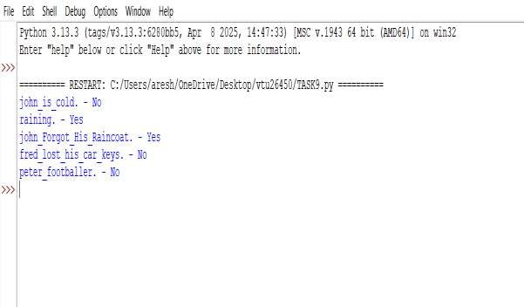

RESULT:
Thus, the implementation of simple facts using python was successfully executed and output was verified.

